**Assignment 10**

**TCOD01**

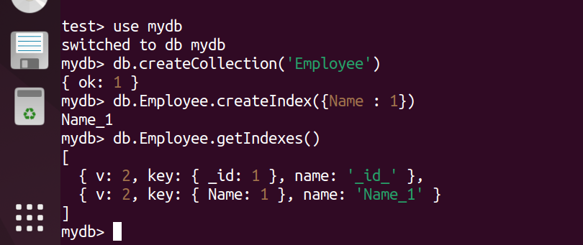

mydb> db.Employee.insert({id:1,Name:"A",salary:80000,Dept:"Comp"})

DeprecationWarning: Collection.insert() is deprecated. Use insertOne, insertMany, or bulkWrite.

{

acknowledged: true,

insertedIds: { '0': ObjectId("635e62fa322c59c36026ba07") } }

mydb> db.Employee.insert({id:2,Name:"B",salary:110000,Dept:"Comp"})

{

acknowledged: true,

insertedIds: { '0': ObjectId("635e6311322c59c36026ba08") } }

mydb> db.Employee.insert({id:3,Name:"C",salary:75000,Dept:"IT"})

{

acknowledged: true,

insertedIds: { '0': ObjectId("635e6334322c59c36026ba09") } }

mydb> db.Employee.insert({id:4,Name:"D",salary:85000,Dept:"IT"})

{

acknowledged: true,

insertedIds: { '0': ObjectId("635e634a322c59c36026ba0a") } }

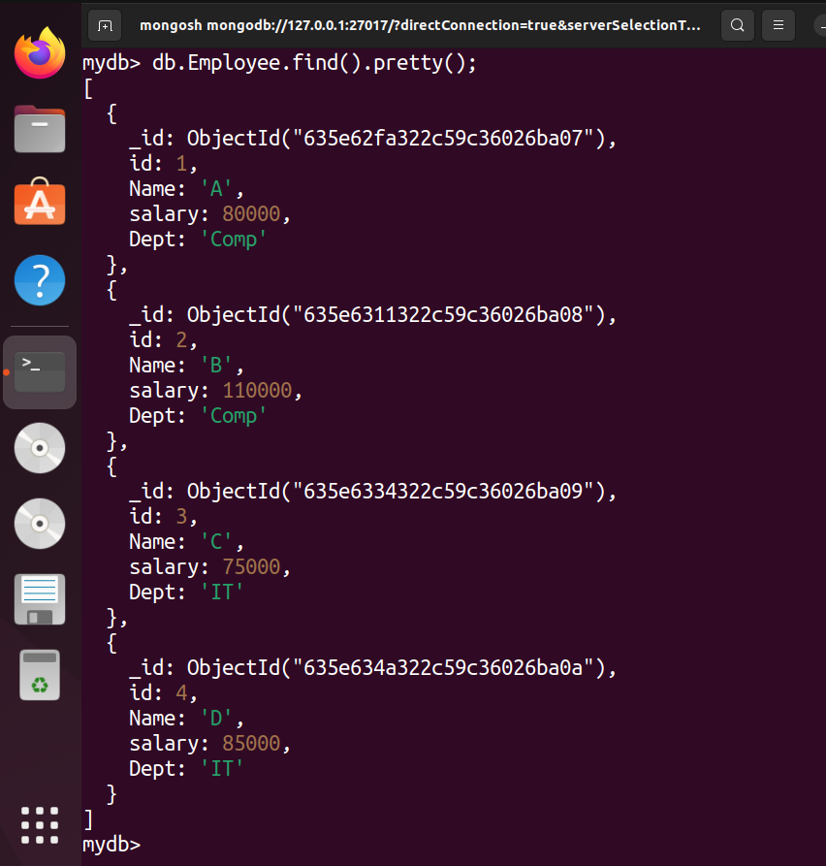

mydb> db.Employee.aggregate([{$match: {Dept:"Comp"}}])

